Name:Amruta S Rabakavi

USN: 2GI23CS017

**Assignment: 7**

**Problem Statement:** All of you need to accomplish the following tasks from an individual perspective such as consider yourself to be owner of an industry, or CEO of a firm or a manager in respective field.

Create envelopes using mail merge to send out greetings to your business partners, co-workers, or employees

While creating the above mentioned see to it to include the following in your document.

·        Create your own style in MS Word.

·        Create a content Page for your Document.

·        add headers and footers to the document with proper heading styles and justification.

**Steps:**

### Step 1: Prepare Your Data in Excel

1. **Open Excel**: Create a new spreadsheet.
2. **Enter Your Data**: Include headers such as:
   * First Name
   * Last Name
   * Company
   * Address
   * City
   * State
   * ZIP Code
3. **Fill in the Rows**: Populate the spreadsheet with your recipients' details.
4. **Save the File**: Save it as "Contacts.xlsx."

### Step 2: Set Up the Word Document

#### Create a Content Page

1. **Open Microsoft Word:** Start a new document.
2. **Insert a New Page for Content:**
   * Press Ctrl + Enter to insert a page break.
3. **Create a Title:**
   * Type “Mail Merge Envelopes” and format it (e.g., bold, 24 pt font).
   * Center align the title.
4. **Add a Table of Contents:**
   * Below the title, list the sections (e.g., "1. Prepare Data," "2. Create Envelopes," "3. Add Headers and Footers").
   * Format the list with appropriate styles (e.g., Heading 1 for main sections).

### Step 3: Create the Envelope

1. **Go to the Mailings Tab:** Click on "Mailings" in the ribbon.
2. **Select Envelopes**: Click on "Envelopes" in the "Create" group**.**
3. **Enter Return Address:** Fill in your return address.
4. **Click “Add to Document”**: This creates a blank envelope layout.

### Step 4: Start Mail Merge

1. **Select Recipients**:
   * In the "Mailings" tab, click "Select Recipients" > "Use an Existing List."
   * Choose your "Contacts.xlsx" file.
2. **Insert Merge Fields**:
   * Click inside the delivery address area of the envelope.
   * Use "Insert Merge Field" to add fields like First Name, Last Name, Company, Address, City, State, and ZIP Code.
   * Format as desired (e.g., use a larger font for names).

### Step 5: Add Headers and Footers

1. **Insert Header**:
   * Go to the "Insert" tab, click "Header," and choose a style.
   * Type the document title or your company name.
   * Format it (e.g., bold, centered).
2. **Insert Footer**:
   * Go to the "Insert" tab, click "Footer," and choose a style.
   * Add page numbers by selecting "Page Number" from the footer options.
   * Include the date if desired.

### Step 6: Preview and Complete the Mail Merge

1. **Preview Results:** Click "Preview Results" in the "Mailings" tab to see how the envelopes look.
2. **Finish & Merge**:Choose "Finish & Merge" > "Print Documents" or "Edit Individual Documents" to create a new document.

### Step 7: Print the Envelopes

1. **Print Directly:** If you selected to print, set your printer options and print.
2. **Edit Individual Documents**: If you created a new document, make final adjustments and print.

### Step 8: Organize and Send

1. **Sort Envelopes:** Organize them as needed.
2. **Deliver or Mail:** Send them out to recipients.

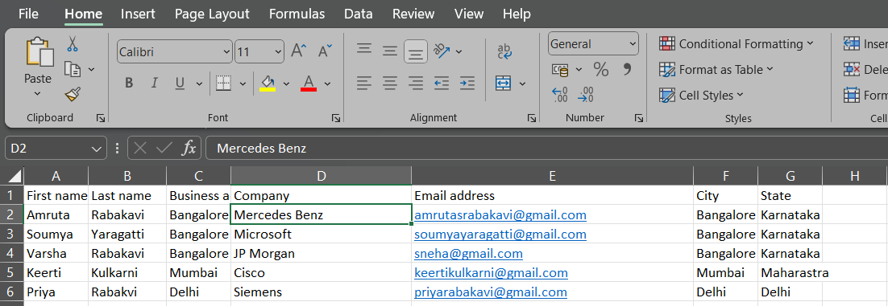

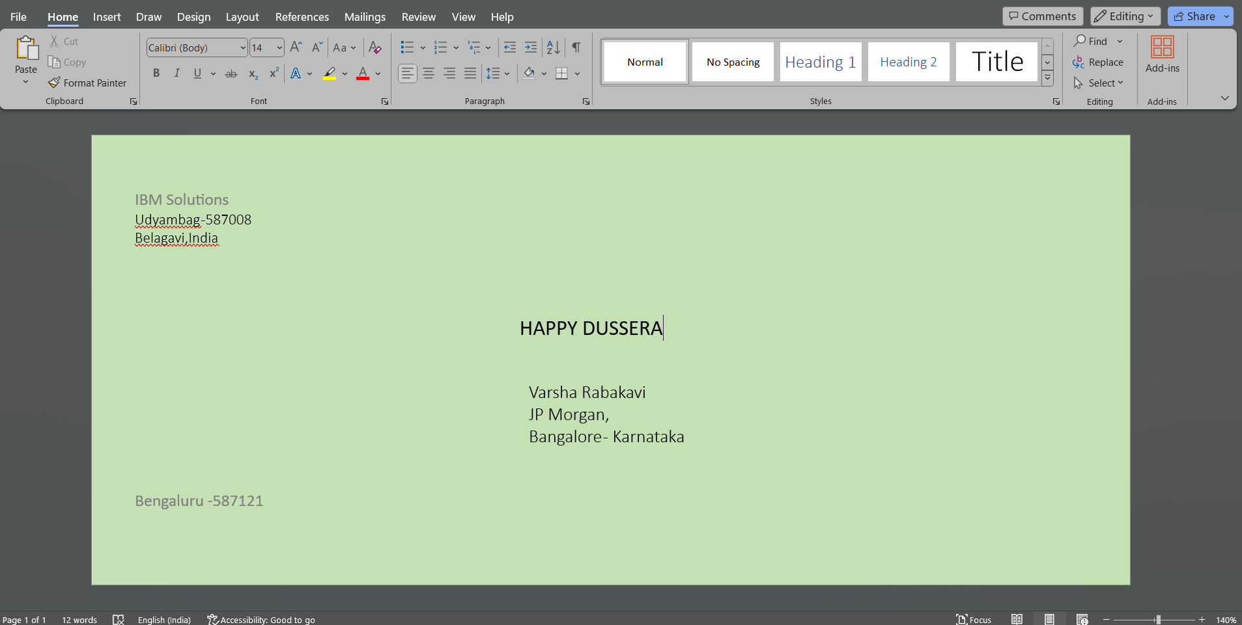**OUTPUT:**

